**Assignment Answers**

Git, Intellij, Html and Css

1. What is the use of the git add command?

Git add stages your changes, telling Git which files you want to include in your next commit. It doesn’t actually save changes to the repository until you commit.

2. Write the command to create a branch “feature-group”.

git branch feature-group or use git checkout -b feature-group

3. What is a pull request? Write the steps involved in creating a pull request.

A pull request lets you tell others about changes you’ve pushed to a branch in a repository. Push your branch, go to GitHub, click “Compare & pull request,” review, and create the pull request.

4. How do you add collaborators?

Go to your GitHub repository’s “Settings”, click “Collaborators”, then add their GitHub username or email. They’ll get an invite to accept and collaborate.

5. What is the command used to commit our changes in github repo?

git commit -m "commit message"

6. Create a github account and repository to save all your assignment tasks. Example repository name: rg-assignments

Create a branch called feature-java(you can use it later to push all your java related tasks to this branch)

Sign up atgithub, click “New” to create a repository named rg-assigments.

git branch feature-java

7. Install IntelliJ IDE. Create a simple java project displaying “Hello World!!”and share the screenshot.

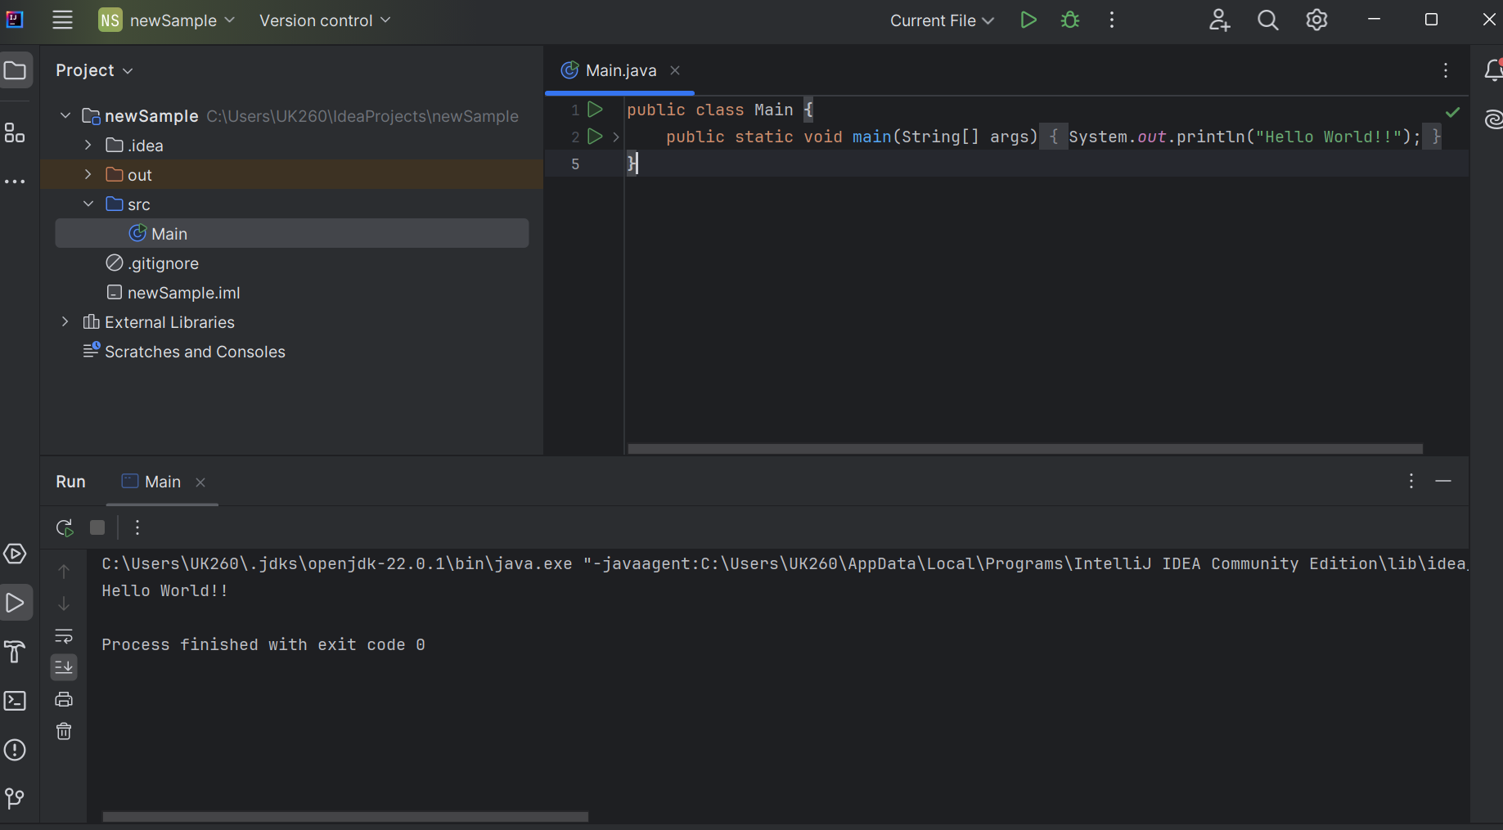

8. In IntelliJ IDE, explore the shortcut keys for the following

To run the project: Shift + F10

To select a line: Home, then Shift + End

To comment/uncomment a line: Ctrl + / (Windows/Linux) or Cmd + / (Mac)

To delete a line: Ctrl + Y (Windows/Linux) or Cmd + Backspace (Mac)

For Html and Css assignment , refer the below github link

<https://github.com/udayykiran/rg-assignments/tree/main/task1>

